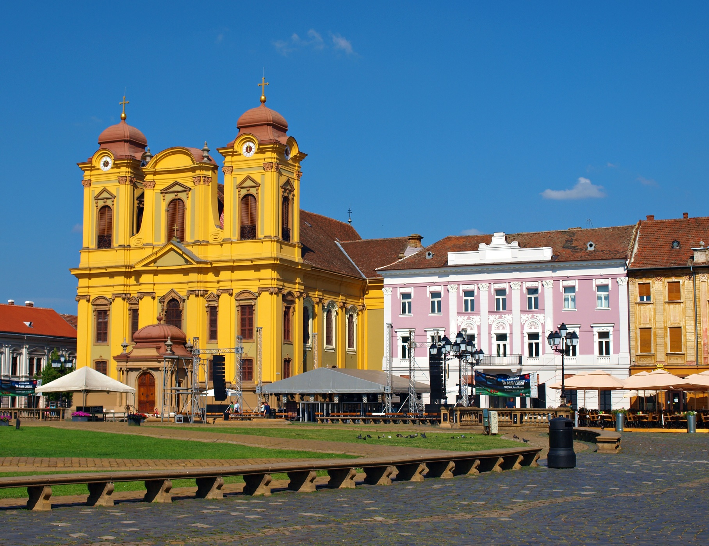
TRADE MISSION TO ROMANIA 2019

Bucharest -Timişoara
22-25 October 2019
WALLONIA - BELGIUM

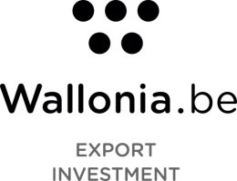

MISSION TO
Timişoara - Bucharest
23-25/10/2019
Organized by Wallonia Export-Investment Agency
with support of EEN Wallonia and West Regional Development Agency - Coordinator of EEN RO-Boost SMEs Consortium for West and South-West of Romania

Table of Contents

WALLONIA EXPORT-INVESTMENT AGENCY 6
WEST REGIONAL DEVELOPMENT AGENCY 7
AMB – ECOSTERYL 9
DISTILLERIE RADERMACHER 10
JOHN COCKERILL ENVIRONMENT 11
LUTOSA 12
MENART 13
POLLET 14
USEFUL CONTACTS 15

ORGANIZERS

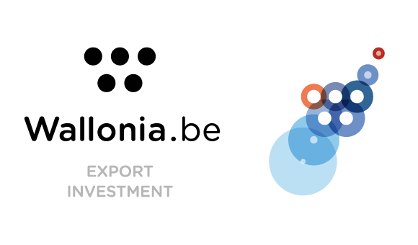
WALLONIA EXPORT-INVESTMENT AGENCY

2, Place Sainctelette
B-1080 Brussels
BELGIUM
T. :+ 32 2 421 82 11
E. :info@awex.be
Website :www.awex.be

CEO : Mrs. Pascale DELCOMMINETTE

The Wallonia Export-Investment Agency (AWEX) is the institution responsible for the development and management of Wallonia's international economic relations with both the international and Wallonia business communities.

Thanks to solutions adapted to each company style and through an innovative and sustainable approach, AWEX supports Walloon exporters in their internationalization projects, regardless of their size, their sector of activity or their target markets.

As part of its mission to attract and support foreign investment, AWEX strengthens Wallonia's position as an essential gateway for international investors wishing to obtain premium access to invest in the Walloon economic fabric and establish themselves in the heart of Europe. Identify, inform, convince and advise, the agency helps the company in each step of its implementation or extension of its activities in our region.

To accomplish its missions, AWEX has a strong local and territorial base as well as a global network of advisors capable of offering market studies and updated sectoral information as well as implementing prospecting activities abroad and thereby promoting Walloon technological excellence to the business community throughout the world.

In addition to these skills, financial support, international financing and training in international professions are also available.

Via our websites, quickly get in touch with one of our local or international agents. In our network of more than 400 employees in nearly 100 countries around the world, there is always someone ready to support you in your approach!

AWEX is member of the Enterprise Europe Network (EEN) and coordinates the EEN Wallonia consortium (for more info see www.eenwallonie.be). The EEN Wallonia consortium offers a wide range of services that heavily rely on the network and its expertise : information, advice and support on the single market and European topics, international partnership support and innovation management.

The B2B session on 23/10 in Timisoara is organized with the support of the EEN Network and in partnership with the West Regional Development Agency, a member of the network in Romania. We thank them!

WEST REGIONAL DEVELOPMENT AGENCY
5, Proclamatia de la Timisoara
300054, Timisoara
ROMANIA
T. : +40 256 491 923
M. : +40 746 156 513
E. : office@adrvest.ro, office-een@adrvest.ro
Website: www.adrvest.ro

Raluca CIBU-BUZAC
Director Regional Policy and Internationalization Directorate
Ro-Boost SMEs Consortium Coordinator

West Regional Development Agency is responsible for implementing the regional development policy in West Region since the creation of the eight development regions in Romania in 1998. In these 20 years of activity West RDA expanded continuously its expertise in:

- Business Support Services :dedicated to internationalization and innovation, as member of theEnterprise Europe Network

- International relations :implementation of international strategic projects funded by the European Commission - https://adrvest.ro/Internationalizare/Proiecte/

- Foreign Direct Investments :dedicated services for business localization in West Region (www.regiuneavest.ro)

- Innovation and technology transfer,including clustering initiatives (www.tehimpuls.ro,www.digivest.ro,www.automotivest.ro)

- Support the development of the innovation ecosystem, including organization of the regional innovation annual eventInnomatch

- Managing Cohesion programs,both Phare and Cohesion Funds - Regional Operational Program 2015-2020 - https://adrvest.ro/por-2014-2020/

- Defining the West Region’s Smart Specialization Strategy(at its 3rdedition now) -https://adrvest.ro/politici-regionale/

PARTICIPANTS

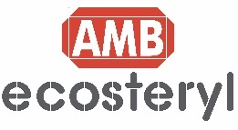

AMB – ECOSTERYL
Andrew CANTILLO
Business Development Specialist

Avenue Nicolas Copernic 1
7000 Mons
BELGIUM
T. : +32 65 82 26 81
M. : +32 472 73 09 43
E. :andrew.cantillo@ecosteryl.com
Facebook : AMB Ecosteryl
Website: www.ecosteryl.com
Linkedin: AMB Ecosteryl

COMPANY BACKGROUND
AMB Ecosteryl is a world leader in the treatment of biomedical waste. The company manufactures machines that integrate a high-tech decontamination system with the use of microwaves. AMB systems, which are part of circular economy and sustainable development initiatives too, don’t reject any contaminated emissions (water, fumes, chemicals nor gas), allow to disinfect any type of medical waste and gives the possibility to recycle and recover the by-product obtained from the process.
ADDED VALUE
- Electricity is the only resource required for the total decontamination of medical waste.
- No water, steam, gas or chemicals.
- The only company in the world offering a 2nd solution for the recycling and recovery of the treated medical waste.
RANGE OF PRODUCTS
Ecosteryl 75, Ecosteryl 125, Ecosteryl 75 Plus, Ecosteryl 250.

MAIN REFERENCES
More than 150 machines installed in more than 50 countries for service providers, health care facilities and municipalities.

CERTIFICATION
- European Directive (CE) Quality Assurance System.
- ISO 9001:2015 - Quality Management Systems.
- Approved for use in the treatment of regulated medical waste in US states: Florida, New York, California.
- Registered and approved by the Russian Federal Service of Health Care and Social development control.
- AMB process has been tested by the Pasteur Institute and approved under the supervision of the Ministry of Health and the Ministry of the Environment by the French Higher Council of Public Health.
- Pasteur Institute (ISO/IEC 17025 International Standard Accredited Laboratory - Accreditation No. 1-2215).

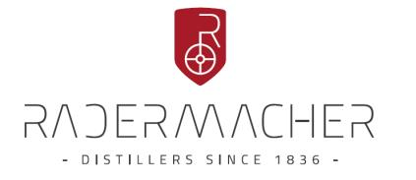

DISTILLERIE RADERMACHER
Yves EMONTS  Directeur commercial  Spitalstrasse, 50  4730 RAEREN  T.: +32 87 85 82 32  E-mail :online@distillerie.biz  Tel : +32 87 85 82 35  M. : +32 475 82 75 25  E. :y.emonts@distillerie.biz | 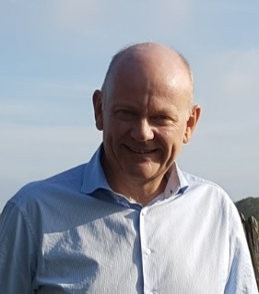
Website : www.distillerie.biz
COMPANY BACKGROUND
Founded in 1836, the Radermacher distillery is the oldest one in Belgium. Today, an experienced team is still producing a wide range of grain and fruit spirits, liqueurs (Chocolate), aperitifs and whisky. For almost 5 years now, it is fully committed to the organic sector and has transformed practically its entire range in this direction.
ADDED VALUE
Two centuries of expertise and a rigorous selection of its raw materials go some way towards explaining the distillation secrets of the Radermacher distillery. Uncompromising on quality, it remains faithful to ancestral traditions and recipes while bowing to the demands of modern production, which come together to create distillates of an exceptional purity.
RANGE OF PRODUCTS
The Radermacher distillery offers a wide range of products: the fruity specialty Woodberries, the Belgian Lambertus whisky and fruity aperitifs made with brandy and natural fruit juice. The distillery also has an exclusively organic range with three gins, a rum, a vodka, a limoncello, a red and white vermouth, a Belgian chocolate liqueur and a genever.
MAIN REFERENCES
The products of the Radermacher distillery are available in specialized shops and in gourmet bars and restaurants. Some brands are also available in a selection of supermarkets in Belgium and abroad.
CERTIFICATION
The Radermacher distillery is not only certified organic, but is also one of the few companies to have received an A rating in its BRC certification, while also being IFS certified.
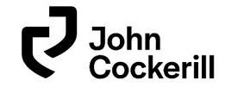

JOHN COCKERILL ENVIRONMENT
Laszlo ORBAN  Director CMI Environment Hungary  Avenue Greiner 1  4100 Seraing  BELGIUM  T. : +32 4 330 24 44  E. : environment.water@cmigroupe.com | 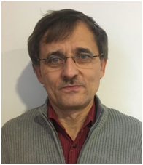  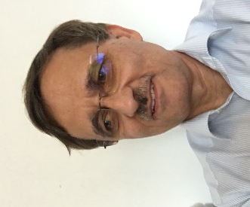
Website: www.johncockerill.com
COMPANY BACKGROUND
John Cockerill Group provides for more than 200 years advanced technologies and services for industry, energy and defense.
With over 5,600 employees in 5 continents, John Cockerill has a turnover of more than one billion euros.
Recently, a sector dedicated to the environment has been created. Acquired companies have extensive expertise and experience in the field of water, air, solid management and chemical reagents and operate in full synergy.

As the Hungarian subsidiary of the John Cockerill Group and part of the division John Cockerill Environment we offer turn-key installations for corrosive, harmful and odorous gas treatment (ventilation systems, gas scrubbers, bio filters, industrial tanks made of thermoplastics). In our 2500 m² factory hall we have all the modern conditions to manufacture thermoplastics installation according to European standards.
Water treatment installations are offered as well by our company. John Cockerill Environment Hungary has technicians with over 30 years’ experience in water treatment field.

ADDED VALUE
  - Good quality-price ratio (Belgian and French quality at a lower price, because manufactured in Hungary)
  - Modern technology according to Belgian and French design, precision

RANGE OF PRODUCTS
- Tanks, biofilters, activated carbon filters, scrubbers  - Ventilation tubes (corrosion resistants -in thermoplastics) | - Fans (corrosion resistants -in thermoplastics)  - Water treatment installations
MAIN REFERENCES
Romania : TOTAL/Air treatment Station asphalt station Ozun ;
3 Installations Air treatment at WWTP-s (waste water treatment plants) around SATU-MARE;
1 Scrubber client : BERGBANAT /Hot deep galvanizing plant city FĂGĂRAŞ,
3 Scrubber client : HERAUS / city Timisoara;
1 Water treatment installation CET (Electrical-Thermal Center) city ORADEA.

CERTIFICATION
ISO 9001; ISO 14001; ISO 45001

LUTOSA
Jaak DE GRAEVE  Regional Sales Manager - Scandinavia, CEE & CIS Countries  Bostjan MEGLIC  Sales Manager former Yugoslavia and Romania  Zone Industrielle du Vieux Pont 5  7900 Leuze-En-Hainaut  BELGIUM  T. : 32-(0)69668211  E. : headoffice@lutosa.com,  walkiria.zegarra@lutosa.com  Website: www.lutosa.com | 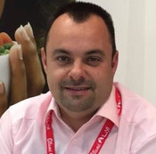
COMPANY BACKGROUND
Lutosa has been successfully involved in potato processing since 1978, during which time it has built an excellent reputation for product quality and outstanding service. This business, originating from Belgium in the Western part of Europe, runs 2 production sites in Belgium (Leuze-en-Hainaut and St-Eloois-Vijve) and employs 1.000 people. In 2018, the company processed 800.000 tons of potatoes and sold 362.806 tons of finished products. 94% of the production is exported to 137 countries.

ADDED VALUE
The production units are fitted with state-of-the-art equipment, enabling them to produce a very wide product range according to the highest hygiene and quality standards.

RANGE OF PRODUCTS
Pre-fried French fries, frozen (use-by date: 18-24 months) and chilled (use-by date: 26 days)
Frozen potato specialties
Dehydrated potato flakes
Organic French fries, frozen specialties & flakes

MAIN REFERENCES
Frozen French fries and specialties (Pom' Pin, Duchesse, Spicy Wedges, Röstis, Mashed Potatoes) as well as an organic range.
Our R&D gathers ideas and finds the means to adapt to local cultures and new food trends, to improve current and future processes, to develop new products, but also to deal with special requests of our customers. At international trade fairs, we annually present new creations that regularly win special awards.

CERTIFICATION
IFS–BRC certificates (audit by ISACert). Lutosahas its own laboratory BELAC ISO/IEC 17025/2005

MENART
Gilles GODISSART  Business Developper  Rue Benoit 31  7370 Dour  BELGIUM  T. : 32-65 61 07 60  E. :info@menart.eu | 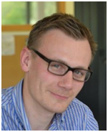
Website: www.menart.eu
COMPANY BACKGROUND
Ménart is a family company founded in 1961. Historically linked to the agricultural world in composting effluents and in the valorisation of livestock by-products, Ménart has specialised in the valorisation of organic waste (household waste, green waste, palms, cane sugar, manure, etc.) among others. Its expertise is now recognized in more than sixty countries around the world. Ménart has also developed tractor power take-off machines for road maintenance.
ADDED VALUE
Ménart is a “full liner” in organic waste recovery machines (manure, garbage, green waste) which declines its lines in diesel and electric version, but also in tractor power take-off. Our range enables manufacturers and farmers to recycle their waste while maximizing the output of their tractor.
RANGE OF PRODUCTS
High speed shredder  H102-H121-P145-P160  Windrows turner  Tractor PTO: SP-30/SP-40/SP-45/SP-50/SP-60  Self-propelled: SPM36/SPM47/SPM58/SPM63/SPM73  Screen  Stationary screen: TS | Mobile screen: TR 1535/TR 1950/TR 1960  Semi mobile compact screen: TSC 1535/TSC 1950/TSC 1960  Road maintenance  EXCAROTOR  DMO (mechanical weeder)  Road side scraper
MAIN REFERENCES
UK: Veolia, Shanks UK, Greenways, Envar,
Bulgaria: City of Bourgas (Bulgaria)
France : Communauté de communes de Béziers (France), la Ferme du Rafidin, RECYDEM
Vietnam: Sonadezi, Soc Trang, ...
Poland: Newkom
Pakistan: Lahore Compost
CERTIFICATION
ISO 9001.
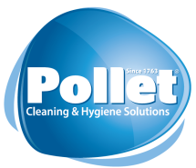

POLLET
Steven KNOCKAERT  Export Manager  Rue de la Grande Couture 20  7501 Tournai  BELGIUM  T. : +32 69 22 21 21  M. : +32 499 88 97 76  E. : s.knockaert@pollet.eu | 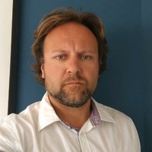
Website: www.pollet.eu
COMPANY BACKGROUND
The Pollet Company is a family business founded in 1763. It is specialized in research, manufacturing and marketing of maintenance products for hygiene and cleaning. Pollet has 4 similar but different activities: the manufacture of oil, the manufacture of green soap, liquid soap (linpol, started after WW2, still an innovation on the market of big surfaces), ecologic and biotechnological cleaning products. In 1993 Pollet was a pioneer in the biotechnological cleaning products. In 2006, it was the 2nd company in Belgium to develop an ecolabel product.
ADDED VALUE
As specialists dedicated to cleaning professionals, we are experts in biotechnologies, and leaders of sustainable development through a massive offer or efficient and eco-certified products. We offer powerful, economic solutions with strong added value combining durable high-technology products and customized service. We payvery special attention to ecology: in 2017, more than 55% of our production was ecological and we are aiming for constant progress in the future. Pollet has a sustained 25% growth since 2015 and is present in 15 European countries, in North America and Canada. Sales offers address professionals (Education, Health, BSC) through Jan San Distributor’s.
RANGE OF PRODUCTS
We deliver a high-quality range of products and solutions to major international cleaning contractors, large collectivises, industrial plants, retail centres. Our R&D team designs environment-friendly formulas, both for green-labelled products (Polgreen range) and for biotechnological products (Polbio and POLVITA range). This innovative approach makes us leaders in the production and sale of sustainable products. We are one of the only manufacturers to offer a huge range of professional products with three ecological certifications recognized worldwide: European Ecolabel, Ecologo and Green seal. Our products also meet the bio-based standard, meaning that our raw materials are of renewable origin. Our Product development is based on 4 pillars: Efficiency, Safety, Ecology and Productivity. Our products are designed to meet very precise specifications based on ecological efficiency.
MAIN REFERENCES
Auchan, Carrefour, Bosch, Grand Central Terminal, Airbus, Bombardier, Quick, Bosch, Renault, Alstom, Sinclea, Atalian, Glanz, Thermae Bucuresti
CERTIFICATION
ISO 9001-2015, “Responsible Cleaning” certified

USEFUL CONTACTS
BELGIUM

AWEX

Dominique TOURNEUR
Deputy General Manager European Markets
PlaceSainctelette, 2
1080 Brussels
Belgium
Phone: +32 2 421 82 54
d.tourneur@awex.be

Evgeniya ULKINA
Area Manager South-Eastern Europe
and South-Caucasus
PlaceSainctelette, 2
1080 Brussels
Belgium
Phone: +32 2 421 86 61
e.ulkina@awex.be

Vincent VAN BREUSEGEM
EEN Wallonia coordinator
Avenue des Dessus de Lives, 6
5101 Namur-Loyers
Belgium
Phone : +32 81 33 28 55
v.vanbreusegem@awex.be

ROMANIA
Anne DEFOURNY
AWEX Trade Commissioner
Wallonia Export-Investment Agency
StirbeiVodastreet 26-28,
010113 Bucharest 1
Romania
Phone: +40 (0)21 314 05 77
bucarest@awex-wallonia.com

Cristina SZASZ-CUSI
AWEX Commercial Assistant
Wallonia Export-Investment Agency
StirbeiVodastreet 26-28,
010113 Bucharest 1
Romania
Phone: +40 (0)21 314 05 77
bucarest@awex-wallonia.com

AWEX
WALLONIA EXPORT – INVESTMENT AGENCY
Place Sainctelette, 2 • 1080 BRUSSELS • BELGIUM
Tel: +32 2 421 82 11
info@awex.be
www.awex-export.be • www.investinwallonia.be • www.wallonia.be

#WALmissionROU

